CO3 AT1 Experiment
DSA 0201 – Computer Vision with Open cv
Name: K. Madhulika
Reg no: 192524190

Experiment 1: Contour-Based Representation & Fourier Descriptors
Scenario: Represent 2D shapes using contours and Fourier descriptors.
Input Data:
A. Binary images of 2D hand-drawn letters (A–Z) or simple symbols (triangle,
square, star)
B. Image size: 256 × 256 pixels
C. File format: PNG or BMP
Program:
import cv2
import numpy as np
import matplotlib.pyplot as plt
from tkinter import Tk
from tkinter.filedialog import askopenfilename
# --------------------------------------------------
# STEP 1: Select the input image
# --------------------------------------------------
Tk().withdraw()
file_path = askopenfilename(
title="Select a Binary Image",
filetypes=[
("Image Files", "*.png *.bmp"),
("PNG Files", "*.png"),
("BMP Files", "*.bmp")
]
)
if file_path == "":
print("No image selected.")
exit()
# --------------------------------------------------
# STEP 2: Read the image
# --------------------------------------------------
image = cv2.imread(file_path, cv2.IMREAD_GRAYSCALE)
if image is None:
print("Error: Could not read the image.")
exit()
print("Image loaded successfully.")
print("Image size:", image.shape)
# --------------------------------------------------
# STEP 3: Resize image to 256 x 256
# --------------------------------------------------
image = cv2.resize(image, (256, 256))
# --------------------------------------------------
# STEP 4: Convert image into binary image
# --------------------------------------------------
_, binary = cv2.threshold(
image, 127, 255, cv2.THRESH_BINARY
)
# --------------------------------------------------
# STEP 5: Find contours
# --------------------------------------------------
contours, hierarchy = cv2.findContours(
binary,
cv2.RETR_EXTERNAL,
cv2.CHAIN_APPROX_NONE
)
if len(contours) == 0:
print("No contour found.")
exit()
# Select the largest contour
contour = max(contours, key=cv2.contourArea)
print("Number of contour points:", len(contour))
# --------------------------------------------------
# STEP 6: Extract contour coordinates
# --------------------------------------------------
points = contour[:, 0, :]
x = points[:, 0]
y = points[:, 1]
# Convert x and y coordinates into complex numbers
complex_contour = x + 1j * y
# --------------------------------------------------
# STEP 7: Calculate Fourier Descriptors
# --------------------------------------------------
fourier = np.fft.fft(complex_contour)
print("\nFourier Descriptors:")
print(fourier[:10])
# --------------------------------------------------
# STEP 8: Select important Fourier descriptors
# --------------------------------------------------
N = len(fourier)
# Number of descriptors to retain
num_descriptors = 20
# Create an array containing only selected descriptors
filtered_fourier = np.zeros_like(fourier)
# Keep low-frequency components
half = num_descriptors // 2
filtered_fourier[:half] = fourier[:half]
filtered_fourier[-half:] = fourier[-half:]
# --------------------------------------------------
# STEP 9: Reconstruct contour
# --------------------------------------------------
reconstructed = np.fft.ifft(filtered_fourier)
reconstructed_x = reconstructed.real
reconstructed_y = reconstructed.imag
# --------------------------------------------------
# STEP 10: Display results
# --------------------------------------------------
plt.figure(figsize=(12, 8))
# Original image
plt.subplot(2, 2, 1)
plt.imshow(image, cmap="gray")
plt.title("Original Image")
plt.axis("off")
# Binary image
plt.subplot(2, 2, 2)
plt.imshow(binary, cmap="gray")
plt.title("Binary Image")
plt.axis("off")
# Contour
plt.subplot(2, 2, 3)
plt.imshow(image, cmap="gray")
plt.plot(x, y, linewidth=2)
plt.title("Detected Contour")
plt.axis("equal")
plt.axis("off")
# Fourier reconstructed shape
plt.subplot(2, 2, 4)
plt.plot(reconstructed_x, reconstructed_y)
plt.gca().invert_yaxis()
plt.title("Fourier Descriptor Reconstruction")
plt.axis("equal")
plt.tight_layout()
plt.show()
# --------------------------------------------------
# STEP 11: Display basic information
# --------------------------------------------------
print("\n----------------------------------")
print("EXPERIMENT COMPLETED")
print("----------------------------------")
print("Input image:", file_path)
print("Image size: 256 x 256")
print("Contour points:", len(contour))
print("Fourier descriptors used:", num_descriptors)
print("Shape representation completed successfully.")
Output:
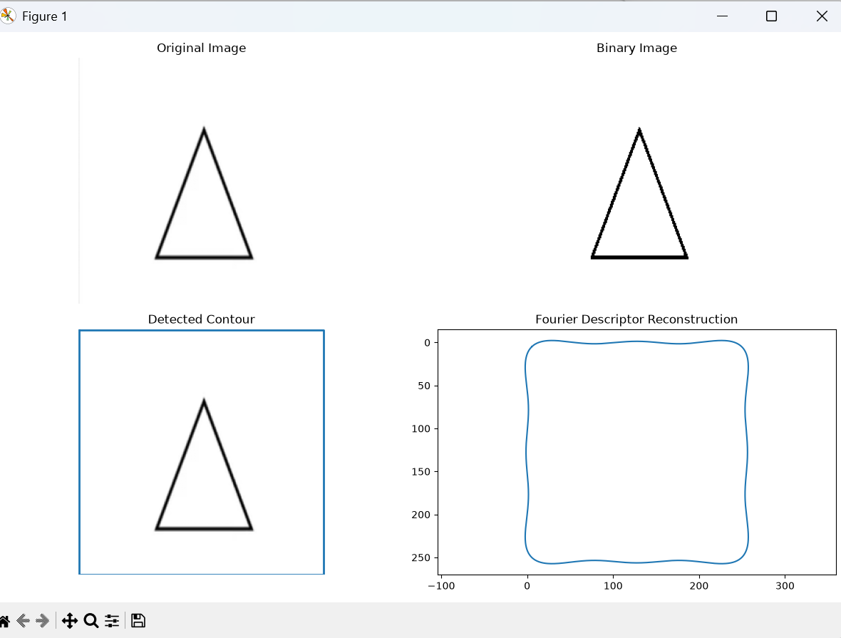

Experiment 2: Region-Based Representation & Medial Axis
Scenario: Analyze object shapes in binary images using medial axis.
Input Data:
A. Binary images of industrial components (e.g., gears, machine parts)
B. Image size: 512 × 512 pixels
C. Defects like small holes, protrusions, or missing parts included
D. File format: PNG
Program:
import cv2
import numpy as np
import matplotlib.pyplot as plt
from tkinter import Tk
from tkinter.filedialog import askopenfilename
# -----------------------------------------
# STEP 1: Select PNG image
# -----------------------------------------
Tk().withdraw()
file_path = askopenfilename(
title="Select Industrial Component Image",
filetypes=[("PNG Files", "*.png")]
)
if file_path == "":
print("No image selected.")
exit()
# -----------------------------------------
# STEP 2: Read image
# -----------------------------------------
image = cv2.imread(file_path, cv2.IMREAD_GRAYSCALE)
if image is None:
print("Error: Image could not be read.")
exit()
print("Image loaded successfully.")
# -----------------------------------------
# STEP 3: Resize to 512 x 512
# -----------------------------------------
image = cv2.resize(image, (512, 512))
# -----------------------------------------
# STEP 4: Convert to binary image
# -----------------------------------------
_, binary = cv2.threshold(
image, 127, 255, cv2.THRESH_BINARY
)
# -----------------------------------------
# STEP 5: Make object white
# -----------------------------------------
# If the object is black and background is white,
# invert the image.
if np.mean(binary) > 127:
binary = cv2.bitwise_not(binary)
# -----------------------------------------
# STEP 6: Remove small noise
# -----------------------------------------
kernel = np.ones((3, 3), np.uint8)
clean_image = cv2.morphologyEx(
binary,
cv2.MORPH_OPEN,
kernel
)
# -----------------------------------------
# STEP 7: Find contours
# -----------------------------------------
contours, hierarchy = cv2.findContours(
clean_image,
cv2.RETR_EXTERNAL,
cv2.CHAIN_APPROX_SIMPLE
)
print("Number of objects detected:", len(contours))
# -----------------------------------------
# STEP 8: Calculate region properties
# -----------------------------------------
if len(contours) > 0:
largest_contour = max(
contours,
key=cv2.contourArea
)
area = cv2.contourArea(largest_contour)
perimeter = cv2.arcLength(
largest_contour,
True
)
x, y, w, h = cv2.boundingRect(
largest_contour
)
print("\nRegion Properties")
print("-------------------------")
print("Area :", area)
print("Perimeter :", perimeter)
print("Width :", w)
print("Height :", h)
# -----------------------------------------
# STEP 9: Medial Axis / Skeleton
# -----------------------------------------
# Skeletonization using morphological operations
skeleton = np.zeros(
clean_image.shape,
np.uint8
)
temp = clean_image.copy()
while True:
# Erode the image
eroded = cv2.erode(
temp,
kernel
)
# Dilate the eroded image
opened = cv2.dilate(
eroded,
kernel
)
# Find the difference
difference = cv2.subtract(
temp,
opened
)
# Add the difference to skeleton
skeleton = cv2.bitwise_or(
skeleton,
difference
)
temp = eroded.copy()
# Stop when image becomes empty
if cv2.countNonZero(temp) == 0:
break
# -----------------------------------------
# STEP 10: Display results
# -----------------------------------------
plt.figure(figsize=(12, 8))
# Original image
plt.subplot(2, 2, 1)
plt.imshow(image, cmap="gray")
plt.title("Original Image")
plt.axis("off")
# Binary image
plt.subplot(2, 2, 2)
plt.imshow(clean_image, cmap="gray")
plt.title("Binary Region")
plt.axis("off")
# Contour
contour_image = cv2.cvtColor(
image,
cv2.COLOR_GRAY2RGB
)
cv2.drawContours(
contour_image,
[largest_contour],
-1,
(255, 0, 0),
2
)
plt.subplot(2, 2, 3)
plt.imshow(contour_image)
plt.title("Object Boundary")
plt.axis("off")
# Medial axis
plt.subplot(2, 2, 4)
plt.imshow(skeleton, cmap="gray")
plt.title("Medial Axis / Skeleton")
plt.axis("off")
plt.tight_layout()
plt.show()
# -----------------------------------------
# STEP 11: Final message
# -----------------------------------------
print("\n--------------------------------")
print("EXPERIMENT COMPLETED")
print("--------------------------------")
print("Image size: 512 x 512")
print("Region-based representation completed.")
print("Medial axis / skeleton extracted successfully.")
Output:
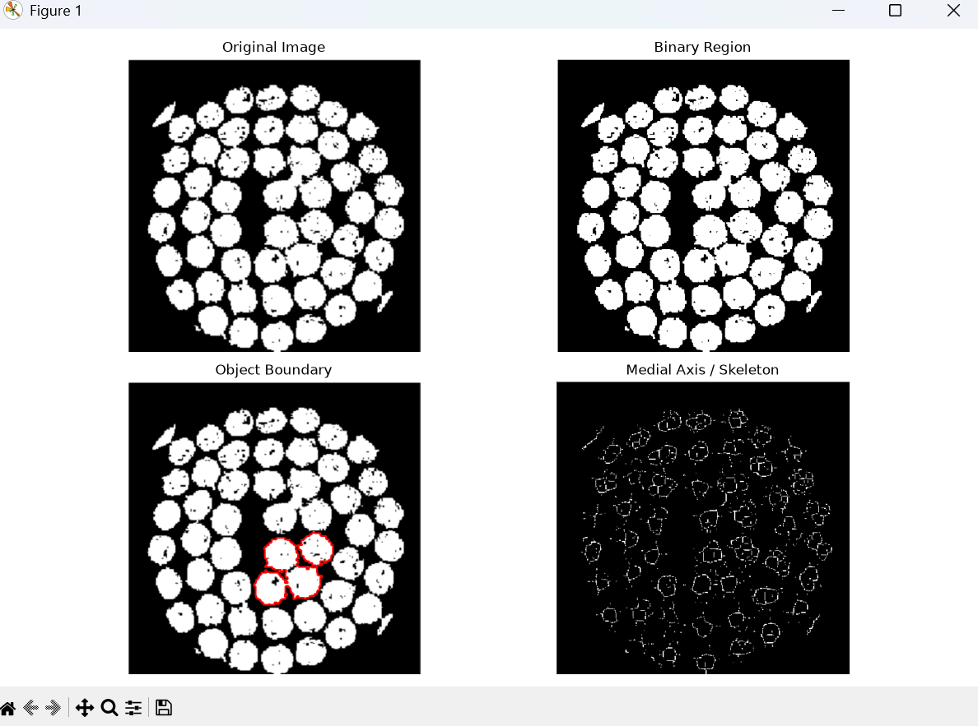
Experiment 3: Deformable Curves and Snakes (Active Contours)
Scenario: Segment organs or objects with irregular boundaries.
Input Data:
A. Grayscale medical images (e.g., liver or heart slices)
B. Image size: 512 × 512 pixels
C. Noise: mild Gaussian noise
D. File format: DICOM or PNG
Program:
import cv2
import numpy as np
import matplotlib.pyplot as plt
from tkinter import Tk
from tkinter.filedialog import askopenfilename
from skimage.segmentation import active_contour
from skimage.filters import gaussian
# --------------------------------------------------
# STEP 1: Select image
# --------------------------------------------------
Tk().withdraw()
file_path = askopenfilename(
title="Select Medical Image",
filetypes=[
("Medical Images", "*.png *.dcm"),
("PNG Files", "*.png"),
("DICOM Files", "*.dcm")
]
)
if file_path == "":
print("No image selected.")
exit()
# --------------------------------------------------
# STEP 2: Read image
# --------------------------------------------------
if file_path.lower().endswith(".dcm"):
try:
import pydicom
dicom_data = pydicom.dcmread(file_path)
image = dicom_data.pixel_array
# Normalize DICOM image
image = image.astype(np.float32)
image = image - np.min(image)
if np.max(image) != 0:
image = image / np.max(image)
image = (image * 255).astype(np.uint8)
except ImportError:
print("pydicom is not installed.")
print("Install it using: pip install pydicom")
exit()
else:
image = cv2.imread(
file_path,
cv2.IMREAD_GRAYSCALE
)
# Check image
if image is None:
print("Error: Could not read image.")
exit()
print("Image loaded successfully.")
# --------------------------------------------------
# STEP 3: Resize image to 512 x 512
# --------------------------------------------------
image = cv2.resize(
image,
(512, 512)
)
print("Image size:", image.shape)
# --------------------------------------------------
# STEP 4: Normalize image
# --------------------------------------------------
image = image.astype(np.float32)
image = image - np.min(image)
if np.max(image) != 0:
image = image / np.max(image)
# --------------------------------------------------
# STEP 5: Add mild Gaussian noise
# --------------------------------------------------
noise = np.random.normal(
0,
0.03,
image.shape
)
noisy_image = image + noise
noisy_image = np.clip(
noisy_image,
0,
1
)
# --------------------------------------------------
# STEP 6: Remove noise using Gaussian smoothing
# --------------------------------------------------
smooth_image = gaussian(
noisy_image,
sigma=2
)
# --------------------------------------------------
# STEP 7: Create initial snake
# --------------------------------------------------
# Center of image
center_x = 256
center_y = 256
# Initial radius
radius = 150
# Number of points
points = 200
theta = np.linspace(
0,
2 * np.pi,
points
)
# Create circular initial contour
x = center_x + radius * np.cos(theta)
y = center_y + radius * np.sin(theta)
# skimage uses (row, column) = (y, x)
initial_snake = np.array(
[y, x]
).T
# --------------------------------------------------
# STEP 8: Apply Active Contour
# --------------------------------------------------
snake = active_contour(
smooth_image,
initial_snake,
alpha=0.01,
beta=1.0,
gamma=0.001,
max_num_iter=500,
convergence=0.1
)
# --------------------------------------------------
# STEP 9: Display results
# --------------------------------------------------
plt.figure(figsize=(12, 8))
# Original image
plt.subplot(2, 2, 1)
plt.imshow(
image,
cmap="gray"
)
plt.title("Original Medical Image")
plt.axis("off")
# Noisy image
plt.subplot(2, 2, 2)
plt.imshow(
noisy_image,
cmap="gray"
)
plt.title("Image with Gaussian Noise")
plt.axis("off")
# Initial contour
plt.subplot(2, 2, 3)
plt.imshow(
smooth_image,
cmap="gray"
)
plt.plot(
initial_snake[:, 1],
initial_snake[:, 0],
"--",
linewidth=2
)
plt.title("Initial Snake")
plt.axis("off")
# Final contour
plt.subplot(2, 2, 4)
plt.imshow(
smooth_image,
cmap="gray"
)

plt.plot(
snake[:, 1],
snake[:, 0],
linewidth=2
)
plt.title("Final Active Contour")
plt.axis("off")
plt.tight_layout()
plt.show()
# --------------------------------------------------
# STEP 10: Display result
# --------------------------------------------------
print()
print("----------------------------------")
print("EXPERIMENT COMPLETED")
print("----------------------------------")
print("Image size : 512 x 512")
print("Noise type : Gaussian")
print("Segmentation : Active Contour")
print("Snake points :", len(snake))
print("Organ boundary detected successfully.")

Output: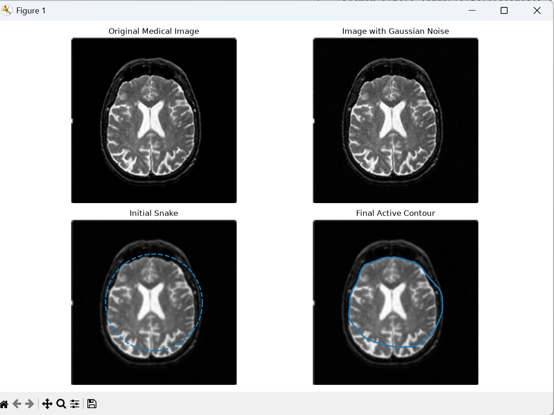

Experiment 4: Level Set Methods
Scenario: Track moving objects with evolving boundaries.
Input Data:
A. Video sequence (30 frames) of a moving object (e.g., a bouncing ball or
moving hand)
B. Resolution: 640 × 480 pixels
C. Format: MP4 or sequence of PNG images
Program:
import cv2
import numpy as np
import matplotlib.pyplot as plt
from tkinter import Tk
from tkinter.filedialog import askopenfilename
# --------------------------------------------------
# STEP 1: Select input image
# --------------------------------------------------
Tk().withdraw()
file_path = askopenfilename(
title="Select Object Image",
filetypes=[
("PNG Files", "*.png"),
("All Image Files", "*.png *.jpg *.jpeg *.bmp")
]
)
if file_path == "":
print("No image selected.")
exit()
# --------------------------------------------------
# STEP 2: Read image
# --------------------------------------------------
image = cv2.imread(
file_path,
cv2.IMREAD_GRAYSCALE
)
if image is None:
print("Error: Could not read image.")
exit()
print("Image loaded successfully.")
# --------------------------------------------------
# STEP 3: Resize image to 640 x 480
# --------------------------------------------------
image = cv2.resize(
image,
(640, 480)
)
print("Image size: 640 x 480")
# --------------------------------------------------
# STEP 4: Blur image to reduce noise
# --------------------------------------------------
blurred = cv2.GaussianBlur(
image,
(5, 5),
0
)
# --------------------------------------------------
# STEP 5: Detect edges
# --------------------------------------------------
edges = cv2.Canny(
blurred,
50,
150
)
# --------------------------------------------------
# STEP 6: Create initial level set
# --------------------------------------------------
height, width = image.shape
# Create a circular initial contour
center_x = width // 2
center_y = height // 2
radius = 100
Y, X = np.ogrid[:height, :width]
distance = np.sqrt(
(X - center_x) ** 2 +
(Y - center_y) ** 2
)
# Level set function
phi = distance - radius
# --------------------------------------------------
# STEP 7: Evolve the level set
# --------------------------------------------------
iterations = 100
for i in range(iterations):
# Calculate gradients
grad_x = np.gradient(phi, axis=1)
grad_y = np.gradient(phi, axis=0)
# Calculate gradient magnitude
gradient_magnitude = np.sqrt(
grad_x ** 2 +
grad_y ** 2
)
# Avoid division by zero
gradient_magnitude[
gradient_magnitude == 0
] = 1
# Normalize gradients
nx = grad_x / gradient_magnitude
ny = grad_y / gradient_magnitude
# Calculate curvature
nxx = np.gradient(nx, axis=1)
nyy = np.gradient(ny, axis=0)
curvature = nxx + nyy
# Edge stopping function
edge_function = 1 / (
1 + edges.astype(float) / 255
)
# Level set update
phi = phi + (
0.5 *
edge_function *
curvature
)
# --------------------------------------------------
# STEP 8: Extract final boundary
# --------------------------------------------------
final_boundary = np.abs(phi) < 1.5
# --------------------------------------------------
# STEP 9: Create result image
# --------------------------------------------------
result = cv2.cvtColor(
image,
cv2.COLOR_GRAY2RGB
)
result[final_boundary] = [255, 0, 0]
# --------------------------------------------------
# STEP 10: Display results
# --------------------------------------------------
plt.figure(figsize=(12, 8))
# Original image
plt.subplot(2, 2, 1)
plt.imshow(
image,
cmap="gray"
)
plt.title("Original Image")
plt.axis("off")
# Edge image
plt.subplot(2, 2, 2)
plt.imshow(
edges,
cmap="gray"
)
plt.title("Edge Detection")
plt.axis("off")
# Initial level set
plt.subplot(2, 2, 3)
plt.imshow(
image,
cmap="gray"
)
initial_boundary = np.abs(
distance - radius
) < 1.5
plt.contour(
initial_boundary,
colors="red"
)
plt.title("Initial Level Set")
plt.axis("off")
# Final level set
plt.subplot(2, 2, 4)
plt.imshow(result)
plt.title("Final Level Set Boundary")
plt.axis("off")
plt.tight_layout()
plt.show()
# --------------------------------------------------
# STEP 11: Final output
# --------------------------------------------------
print()
print("----------------------------------")
print("EXPERIMENT COMPLETED")
print("----------------------------------")
print("Image size : 640 x 480")
print("Number of iterations:", iterations)
print("Level Set Method : Completed")
print("Object boundary : Extracted")

Output:
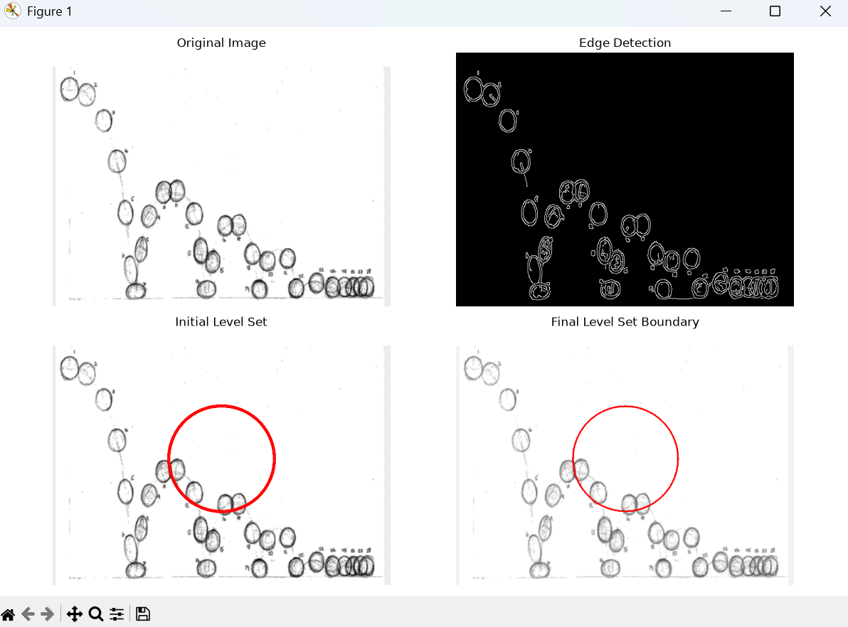

Experiment 5: Multi-Resolution & Wavelet Descriptors
Scenario: Shape recognition at multiple scales.
Input Data:
A. Grayscale images of objects at different scales (e.g., leaves, mechanical parts,
coins)
B. Image sizes: 128 × 128, 256 × 256, 512 × 512 pixels
C. Format: PNG
Program:
import cv2
import numpy as np
import matplotlib.pyplot as plt
from tkinter import Tk
from tkinter.filedialog import askopenfilename
# --------------------------------------------------
# STEP 1: Select PNG image
# --------------------------------------------------
Tk().withdraw()
file_path = askopenfilename(
title="Select Object Image",
filetypes=[
("PNG Files", "*.png")
]
)
if file_path == "":
print("No image selected.")
exit()
# --------------------------------------------------
# STEP 2: Read image
# --------------------------------------------------
image = cv2.imread(
file_path,
cv2.IMREAD_GRAYSCALE
)
if image is None:
print("Error: Could not read image.")
exit()
print("Image loaded successfully.")
# --------------------------------------------------
# STEP 3: Create different resolutions
# --------------------------------------------------
image_128 = cv2.resize(
image,
(128, 128)
)
image_256 = cv2.resize(
image,
(256, 256)
)
image_512 = cv2.resize(
image,
(512, 512)
)
print("Created:")
print("128 x 128 image")
print("256 x 256 image")
print("512 x 512 image")
# --------------------------------------------------
# STEP 4: Haar Wavelet Transform
# --------------------------------------------------
def haar_wavelet(image):
# Convert image to float
image = image.astype(np.float64)
# Make dimensions even
rows, cols = image.shape
rows = rows - (rows % 2)
cols = cols - (cols % 2)
image = image[:rows, :cols]
# ----------------------------------------------
# Horizontal transformation
# ----------------------------------------------
average = (
image[:, 0::2] +
image[:, 1::2]
) / 2
difference = (
image[:, 0::2] -
image[:, 1::2]
) / 2
# ----------------------------------------------
# Vertical transformation
# ----------------------------------------------
LL = (
average[0::2, :] +
average[1::2, :]
) / 2
LH = (
average[0::2, :] -
average[1::2, :]
) / 2
HL = (
difference[0::2, :] +
difference[1::2, :]
) / 2
HH = (
difference[0::2, :] -
difference[1::2, :]
) / 2
return LL, LH, HL, HH
# --------------------------------------------------
# STEP 5: Apply Wavelet Transform
# --------------------------------------------------
LL128, LH128, HL128, HH128 = haar_wavelet(
image_128
)
LL256, LH256, HL256, HH256 = haar_wavelet(
image_256
)
LL512, LH512, HL512, HH512 = haar_wavelet(
image_512
)
# --------------------------------------------------
# STEP 6: Calculate Wavelet Descriptors
# --------------------------------------------------
def calculate_descriptors(LL, LH, HL, HH):
descriptor = [
np.mean(np.abs(LL)),
np.mean(np.abs(LH)),
np.mean(np.abs(HL)),
np.mean(np.abs(HH)),
np.std(LL),
np.std(LH),
np.std(HL),
np.std(HH)
]
return descriptor
descriptor_128 = calculate_descriptors(
LL128, LH128, HL128, HH128
)
descriptor_256 = calculate_descriptors(
LL256, LH256, HL256, HH256
)
descriptor_512 = calculate_descriptors(
LL512, LH512, HL512, HH512
)
# --------------------------------------------------
# STEP 7: Display Wavelet Descriptors
# --------------------------------------------------
print("\n----------------------------------")
print("WAVELET DESCRIPTORS")
print("----------------------------------")
print("\n128 x 128:")
print(descriptor_128)
print("\n256 x 256:")
print(descriptor_256)
print("\n512 x 512:")
print(descriptor_512)
# --------------------------------------------------
# STEP 8: Display Multi-Resolution Images
# --------------------------------------------------
plt.figure(figsize=(12, 8))
plt.subplot(2, 3, 1)
plt.imshow(image_128, cmap="gray")
plt.title("128 x 128")
plt.axis("off")
plt.subplot(2, 3, 2)
plt.imshow(image_256, cmap="gray")
plt.title("256 x 256")
plt.axis("off")
plt.subplot(2, 3, 3)
plt.imshow(image_512, cmap="gray")
plt.title("512 x 512")
plt.axis("off")
# --------------------------------------------------
# STEP 9: Display Wavelet Approximation
# --------------------------------------------------
plt.subplot(2, 3, 4)
plt.imshow(LL128, cmap="gray")
plt.title("128x128 - LL")
plt.axis("off")
plt.subplot(2, 3, 5)
plt.imshow(LL256, cmap="gray")
plt.title("256x256 - LL")
plt.axis("off")
plt.subplot(2, 3, 6)
plt.imshow(LL512, cmap="gray")
plt.title("512x512 - LL")
plt.axis("off")
plt.tight_layout()
plt.show()
# --------------------------------------------------
# STEP 10: Display Wavelet Components
# --------------------------------------------------
plt.figure(figsize=(12, 8))
plt.subplot(2, 2, 1)
plt.imshow(LL256, cmap="gray")
plt.title("LL - Approximation")
plt.axis("off")
plt.subplot(2, 2, 2)
plt.imshow(LH256, cmap="gray")
plt.title("LH - Horizontal Details")
plt.axis("off")
plt.subplot(2, 2, 3)
plt.imshow(HL256, cmap="gray")
plt.title("HL - Vertical Details")
plt.axis("off")
plt.subplot(2, 2, 4)
plt.imshow(HH256, cmap="gray")
plt.title("HH - Diagonal Details")
plt.axis("off")
plt.tight_layout()
plt.show()
# --------------------------------------------------
# STEP 11: Final message
# --------------------------------------------------
print("\n----------------------------------")
print("EXPERIMENT COMPLETED")
print("----------------------------------")
print("Multi-resolution analysis completed.")
print("Haar wavelet decomposition completed.")
print("Wavelet descriptors extracted successfully.")
Output:
